# File permissions in Linux

## Project description

The research team needs to update the file permissions for a few files and directories within the projects directory. The authorizations that are currently in place do not meet the level of the authorization that should be given. Checking and updating these permissions will help keep the system secure. To complete this task, I performed the following tasks:

## Check file and directory details

The following snippet shows how I have used Linux commands to determine the existing permissions set for a specific directory named projects in the file system.

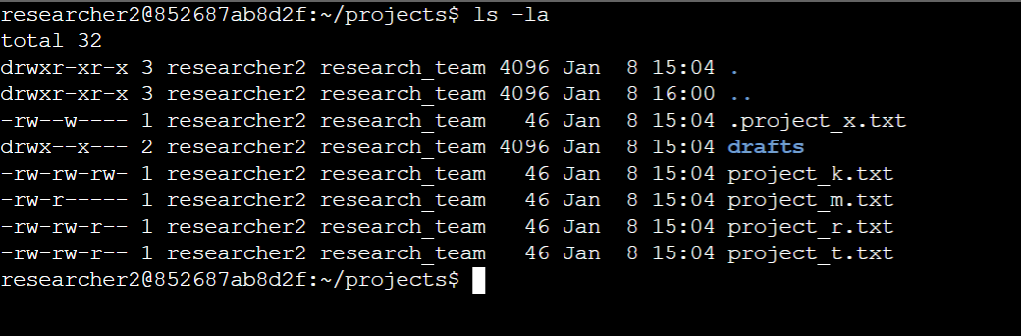

The first line shows the command that I have entered and the rest of the lines display the output. I have used the ls command with the -la option to display a detailed listing of the file contents which also returned hidden files. The output indicates that there is one directory drafts , one hidden file .project_x.txt and five other project files in the projects directory. The 10-character string in the first column represents the permissions set on each file or directory.

## Describe the permissions string

The 10-character string represents the permissions that are set to each file.

* The **first** character represents the file type and it is either a d or hyphen (-) which stands for a directory and regular file respectively.
* **2nd-4th characters** indicate read (r), write (w) and execute (x) permissions for the user, if there is a hyphen (-) instead, it indicates that the permissions are not given to the user. **5th-7th characters** indicate the same thing for the group and **8th-10th characters** indicate the same thing for other (all other users in the system).

## Change file permissions

The organization determined that other shouldn't have write access to any of their files. To comply with this, I cross-checked with the file permissions that I returned using the previous command and determined project_k.txt must have the write access removed for other.

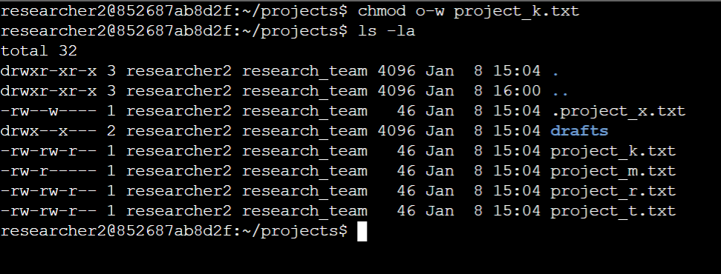

The first two lines of the above snippet show the commands that I entered and the rest of the lines are output. The command chmod changes the permissions of files and directories. The first argument indicate that changes to be made and the second indicate the file name. In this example, I removed write permissions from other for the project_k.txt file. After this, I used ls -la to review the updates I made.

## Change file permissions on a hidden file

The research team recently archived a file name and they do not want anyone to have write access to this file, however the user and group should be able to read this file.

The first two lines of the below snippet show the commands that I entered and the rest of the lines are output. I have removed the write permissions and given read permissions to the file using the chmod command.

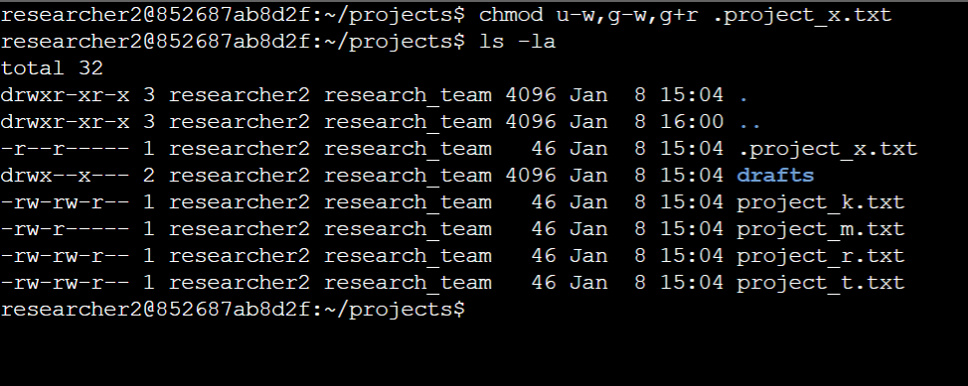

## Change directory permissions

The team only wants the researcher2 user to have access to the drafts directory and its contents. This means that no one other than researcher2 should have execute permissions.

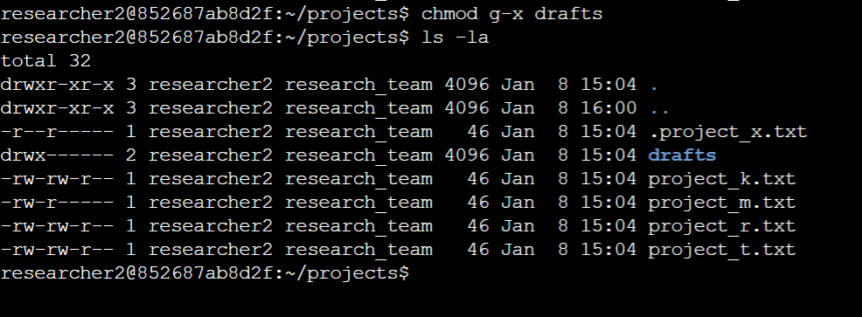

The first two lines of the above snippet show the commands that I entered and the rest of the lines are output. I used the chmod command to remove unwanted permissions.

## Summary

I changed multiple permissions to match the level of authorization my organization wanted for files and directories in the projects directory. The first step in this was using ls -la to check the permissions for the directory. This informed my decisions in the following steps. I then used the chmod command multiple times to change the permissions on files and directories.